Joel Edwards
Course: Java Programming 2
Homework 9
November 26, 2011

I designed this project with the idea generating random data sets along the lines of the original specification. A new data set is generated every time the window is resized or the “Refresh” button is clicked. The number of lines is determined by the value in the JSpinner next to the refresh button (minimum of 5, maximum of 32). The “Sort” button will re-order the lines from shortest to tallest (left to right). The “Default” button sets the lines to the match the values specified in the assignment. This was an easy extension to the project once the majority of the code was complete. The currently displayed graphic can be printed at any time using either clicking the “Print” button or selecting the Print option from the File menu.

The File menu, in addition to printing, allows the user to close the program, or save the current graphic as a PNG image.

The Rectangle class is almost the same as that from one of the projects from Java 1. It has been modified to implement Comparable in order to allow sorting of a Collection of Rectangles.

The Display class manages the generation of a set of Rectangles, and “painting” them to a Graphics object. This means that Display can be used to perform rendering for both printing and displaying to the screen.

The Window class generates and manages the GUI. When printing is requested, the Window class passes a clone of its Display class to a new PrintJob. The cloned Display object ensures that the printed graphic matches what the user saw when they clicked Print, not what is displayed when the PrintJob is actually processed.

The source files and ant build file are at the end of this document.

The build environment is as follows:
- build.xml
- src/Window.java
- src/Display.java
- src/Rectangle.java
- src/PNGFileFilter.java

The file print.jar is built by running ant in the directory containing the build.xml file. Below are screenshots of the program.

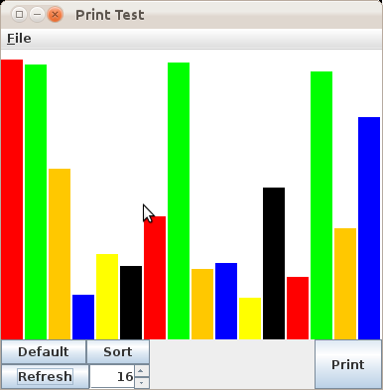

16 Lines after a refresh.
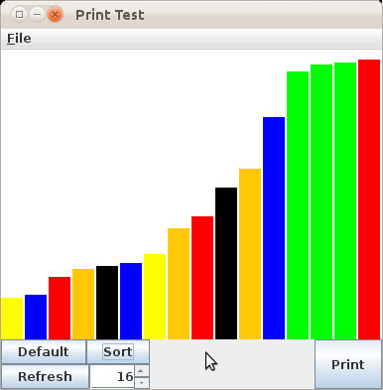

Same as above after a sort.

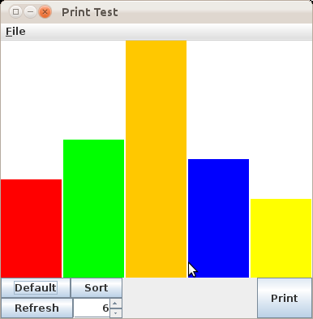

The set specified by the assignment.
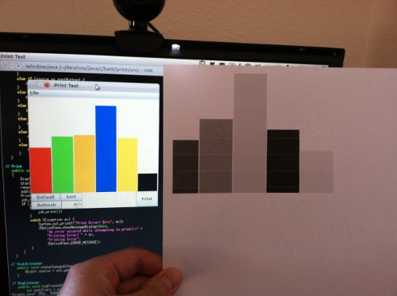

A printout generated by the program (gray-scale since my color cartridge ran out).
The displayed graphic doesn't match because my printer only works on my Apple computer.
Source:

Rectangle.java:
import java.awt.Color;
import java.awt.Graphics;

public class Rectangle
implements Comparable<Rectangle>
{
public static final int MIN_WIDTH = 1;
public static final int MAX_WIDTH = 2048;

public static final int MIN_HEIGHT = 1;
public static final int MAX_HEIGHT = 2048;

public static final int DEFAULT_WIDTH = 10;
public static final int DEFAULT_HEIGHT = 10;
public static final Color DEFAULT_COLOR = Color.BLACK;

private static int lastID = 1;
public final int ID = lastID++;

private int width = DEFAULT_WIDTH;
private int height = DEFAULT_HEIGHT;
private Color color = DEFAULT_COLOR;

public Rectangle() {;}

public Rectangle(int width) {
setWidth(width);
setHeight(width);
}

public Rectangle(int width, int height) {
setWidth(width);
setHeight(height);
}

public Rectangle(int width, int height, Color color) {
setWidth(width);
setHeight(height);
this.color = color;
}

public Rectangle clone() {
return new Rectangle(this.width, this.height, this.color);
}

public void setWidth(int width) {
if (width < MIN_WIDTH) {
this.width = MIN_WIDTH;
}
else if (width > MAX_WIDTH) {
this.width = MAX_WIDTH;
}
else {
this.width = width;
}
}

public void setHeight(int height) {
if (height < MIN_HEIGHT) {
this.height = MIN_HEIGHT;
}
else if (height > MAX_HEIGHT) {
this.height = MAX_HEIGHT;
}
else {
this.height = height;
}
}

public void setColor(Color color) {
this.color = color;
}

public void drawAt(Graphics g, int x, int y) {
Color lastColor = g.getColor();
g.setColor(color);
g.fillRect(x, y, width, height);
g.setColor(lastColor);
}

public boolean equals(Object obj) {
Rectangle other = (Rectangle)obj;
if (width != other.width)
return false;
if (height != other.height)
return false;
if (!(color.equals(other.color)))
return false;
return true;
}

public int compareTo(Rectangle other) {
if (height > other.height)
return 1;
if (height < other.height)
return -1;
return 0;
}

public int computeArea() {
return width * height;
}

public int getWidth() {
return width;
}

public int getHeight() {
return height;
}

public Color getColor() {
return color;
}
}

Display.java:
import java.awt.BorderLayout;
import java.awt.Color;
import java.awt.event.ActionEvent;
import java.awt.event.ComponentListener;
import java.awt.event.ComponentEvent;
import java.awt.Graphics;
import java.awt.Graphics2D;
import java.awt.image.RenderedImage;
import java.awt.image.BufferedImage;
import java.awt.print.PageFormat;
import java.awt.print.Printable;
import java.io.BufferedWriter;
import java.io.File;
import java.io.FileWriter;
import java.util.ArrayList;
import java.util.Collections;
import java.util.Random;
import javax.imageio.ImageIO;
import javax.swing.event.ChangeEvent;
import javax.swing.JDialog;
import javax.swing.JOptionPane;
import javax.swing.JPanel;
import javax.swing.UIManager;

public class Display
extends JPanel
implements Printable
{
private boolean isNew = true;

private Window parent = null;
private File file = null;
private boolean fresh = true;
private boolean saved = true;

private int barSpace = 2;
private Random rand = new Random();

private Color backgroundColor = Color.WHITE;
private int height;
private int width;
private int barWidth = 0;
private ArrayList<Rectangle> rectangles = new ArrayList<Rectangle>();

public Display(Window parent)
{
super();
this.parent = parent;

this.addComponentListener(new ComponentListener() {
public void componentHidden(ComponentEvent e) { ; }
public void componentMoved(ComponentEvent e) { ; }
public void componentResized(ComponentEvent e) {
if (isNew) {
isNew = false;
} else {
((Display)e.getComponent()).refresh();
}
}
public void componentShown(ComponentEvent e) { ; }
});
}

public Display clone()
{
Display display = new Display(this.parent);
display.file = this.file;
display.fresh = this.fresh;
display.saved = this.saved;
display.barSpace = this.barSpace;
display.rand = new Random();
display.backgroundColor = this.backgroundColor;
display.height = this.height;
display.width = this.width;
display.barWidth = this.barWidth;
for (Rectangle rect: this.rectangles) {
display.rectangles.add(rect.clone());
}
return display;
}

public void sortRectangles()
{
Collections.sort(rectangles);
repaint();
}

public void setDefault()
{
width = getWidth();
height = getHeight();

int barCount = 5;
barWidth = (width - ((barCount - 1) * barSpace)) / barCount;

rectangles.clear();
rectangles.add(new Rectangle(barWidth, 5 * height / 12, Color.red));
rectangles.add(new Rectangle(barWidth, 7 * height / 12, Color.green));
rectangles.add(new Rectangle(barWidth, 12 * height / 12, Color.orange));
rectangles.add(new Rectangle(barWidth, 6 * height / 12, Color.blue));
rectangles.add(new Rectangle(barWidth, 4 * height / 12, Color.yellow));
repaint();
}

public void refresh()
{
int barCount = parent.getBarCount();
if (barCount < 1) {
return;
}

width = getWidth();
height = getHeight();

Color color = Color.red;
int barHeight = 0;
int minHeight = height / 8;
int maxHeight = height - (height / 32);
int heightDiff = maxHeight - minHeight;
if (heightDiff < 1) {
heightDiff = 1;
}

barWidth = (width - ((barCount - 1) * barSpace)) / barCount;

rectangles.clear();
for (int i = 0; i < barCount; i++) {
barHeight = minHeight + rand.nextInt(heightDiff);
switch (i % 6) {
case 0: color = Color.red; break;
case 1: color = Color.green; break;
case 2: color = Color.orange; break;
case 3: color = Color.blue; break;
case 4: color = Color.yellow; break;
case 5: color = Color.black; break;
}
rectangles.add(new Rectangle(barWidth, barHeight, color));

}
repaint();
}

public void paint(Graphics g) {
generate(g);
}

public int print(Graphics g, PageFormat pf, int pageIndex)
{
if (pageIndex > 0)
return Printable.NO_SUCH_PAGE;
generate(g);
return Printable.PAGE_EXISTS;
}

public void generate(Graphics g)
{
int startX = 0;
int startY = 0;
g.clearRect(0, 0, width, height);
Rectangle bg = new Rectangle(width, height, backgroundColor);
bg.drawAt(g, 0, 0);
for (Rectangle rect: rectangles) {
startY = height - rect.getHeight();
rect.drawAt(g, startX, startY);
startX += barWidth + barSpace;
}
}

private void setSaved(boolean saved) {
this.fresh = false;
this.saved = saved;
}

public boolean isFresh()
{
return fresh;
}

public boolean isSaved()
{
return saved;
}

public File getFile()
{
return file;
}

public void saveToFile(File file)
{
System.out.println("saveToFile(): " + file);
boolean write = true;
if (file.exists()) {
JOptionPane confirm = new JOptionPane("The file already exists. Do you wish to overwrite it?",
JOptionPane.QUESTION_MESSAGE,
JOptionPane.YES_NO_OPTION,
UIManager.getIcon("OptionPane.questionIcon"));
JDialog dialog = confirm.createDialog("Overwrite File");
dialog.setVisible(true);
Object selectedValue = confirm.getValue();
if (selectedValue != null) {
int value = (Integer)selectedValue;
if (value != JOptionPane.YES_OPTION) {
write = false;
}
}
}
if (write) {
File last = this.file;
this.file = file;
if (store()) {
setSaved(true);
} else {
this.file = last;
}
}
}

public void save() {
if (store()) {
setSaved(true);
}
}

private boolean store() {
// Save to PNG
boolean result = true;
try {
BufferedImage buffered = new BufferedImage(getWidth(), getHeight(),
BufferedImage.TYPE_INT_RGB);
Graphics2D graphics = buffered.createGraphics();
generate(graphics);
//RenderedImage rendered = new RenderedImage();
ImageIO.write(buffered, "png", this.file);
System.out.printf("Successfully wrote to file '%s'\n", this.file);
graphics.dispose();
} catch (Exception e) {
System.out.printf("Failed to write to file '%s'\n", this.file);
result = false;
}
return result;
}
}

PNGFileFilter.java:
import java.io.File;
import javax.swing.filechooser.FileFilter;

public class PNGFileFilter
extends FileFilter
{
public PNGFileFilter()
{
super();
}

public boolean accept(File f)
{
return f.getName().toLowerCase().endsWith(".png");
}

public String getDescription()
{
return "PNG File Filter";
}
}

Window.java:
import java.awt.BorderLayout;
import java.awt.Container;
import java.awt.Dimension;
import java.awt.event.ActionEvent;
import java.awt.event.ActionListener;
import java.awt.event.KeyEvent;
import java.awt.event.KeyListener;
import java.awt.print.PrinterJob;
import java.awt.print.Printable;
import java.io.File;
import javax.swing.event.ChangeEvent;
import javax.swing.event.ChangeListener;
import javax.swing.filechooser.FileFilter;
import javax.swing.JApplet;
import javax.swing.JButton;
import javax.swing.JFileChooser;
import javax.swing.JFrame;
import javax.swing.JMenu;
import javax.swing.JMenuBar;
import javax.swing.JMenuItem;
import javax.swing.JOptionPane;
import javax.swing.JPanel;
import javax.swing.JSpinner;
import javax.swing.SpinnerNumberModel;

public class Window
extends JFrame
implements ActionListener, ChangeListener
{

// Class Components
private String clipboard = null;
private File defaultSaveDir = new File(".");
private Terminator terminator = null;

private boolean isDoubleBuffered = false;

private Display display = new Display(this);

private JPanel buttonPanel = new JPanel(new BorderLayout());
private JButton printButton = new JButton("Print");

private JPanel leftPanel = new JPanel(new BorderLayout());
private JPanel orderPanel = new JPanel(new BorderLayout());
private JButton defaultButton = new JButton("Default");
private JButton sortButton = new JButton("Sort");
private JPanel countPanel = new JPanel(new BorderLayout());
private JButton refreshButton = new JButton("Refresh");
private JSpinner barCountSpinner = new JSpinner();

private JMenuBar menuBar = new JMenuBar();
private JMenu fileMenu = new JMenu("File");

// File Menu Items
private JMenuItem saveFileMenuItem = new JMenuItem("Save", KeyEvent.VK_S);
private JMenuItem saveAsFileMenuItem = new JMenuItem("Save As", KeyEvent.VK_A);
private JMenuItem printFileMenuItem = new JMenuItem("Print", KeyEvent.VK_P);
private JMenuItem quitFileMenuItem = new JMenuItem("Quit", KeyEvent.VK_Q);

public Window(String title)
{
super(title);

getContentPane().setLayout(new BorderLayout());
createMenu();
setJMenuBar(menuBar);

buttonPanel.add(leftPanel, BorderLayout.WEST);
buttonPanel.add(printButton, BorderLayout.EAST);

leftPanel.add(orderPanel, BorderLayout.NORTH);
leftPanel.add(countPanel, BorderLayout.SOUTH);
orderPanel.add(defaultButton, BorderLayout.WEST);
orderPanel.add(sortButton, BorderLayout.CENTER);
countPanel.add(refreshButton, BorderLayout.WEST);
countPanel.add(barCountSpinner, BorderLayout.CENTER);

add(buttonPanel, BorderLayout.SOUTH);
add(display, BorderLayout.CENTER);
pack();

barCountSpinner.setModel(new SpinnerNumberModel(6, 5, 32, 1));

defaultButton.addActionListener(this);
sortButton.addActionListener(this);
refreshButton.addActionListener(this);
printButton.addActionListener(this);

setDefault();
}

public int getBarCount() {
return (Integer)(barCountSpinner.getValue());
}

private void createMenu()
{
// File Menu
fileMenu.setMnemonic(KeyEvent.VK_F);
menuBar.add(fileMenu);
fileMenu.add(saveFileMenuItem);
fileMenu.add(saveAsFileMenuItem);
fileMenu.add(printFileMenuItem);
fileMenu.add(quitFileMenuItem);
saveFileMenuItem.addActionListener(this);
saveAsFileMenuItem.addActionListener(this);
printFileMenuItem.addActionListener(this);
quitFileMenuItem.addActionListener(this);
}

// File Operations
private void refresh()
{
// re-generate bars
display.refresh();
}

private void setDefault()
{
display.setDefault();
}

private void sortRectangles()
{
display.sortRectangles();
}

private void save()
{
// save as a PNG file...
if (display.getFile() == null) {
saveAs();
} else {
display.save();
}
}

private void saveAs()
{
JFileChooser fileChooser = new JFileChooser();
fileChooser.setDialogTitle("Save As File");
fileChooser.setCurrentDirectory(defaultSaveDir);
fileChooser.setMultiSelectionEnabled(false);
fileChooser.setFileFilter(new PNGFileFilter());
int returnVal = fileChooser.showSaveDialog(this);
if (returnVal == JFileChooser.APPROVE_OPTION)
{
defaultSaveDir = fileChooser.getCurrentDirectory();
File file = fileChooser.getSelectedFile();
display.saveToFile(file);
}
}

// Quit the Application
private void quit() {
System.exit(0);
}

// ActionListener
public void actionPerformed(ActionEvent evt)
{
Object source = evt.getSource();
if (source == refreshButton) {
refresh();
}
else if (source == defaultButton) {
setDefault();
}
else if (source == sortButton) {
sortRectangles();
}
else if (source == printButton) {
print();
}
else if (source == printFileMenuItem) {
print();
}
else if (source == saveFileMenuItem) {
save();
}
else if (source == saveAsFileMenuItem) {
saveAs();
}
else if (source == quitFileMenuItem) {
quit();
}
}

// Print
public void print()
{
Display printDisplay = display.clone();
PrinterJob job = PrinterJob.getPrinterJob();
job.setPrintable((Printable)printDisplay);
if (job.printDialog()) {
try {
job.print();
}
catch (Exception ex) {
System.out.printf("Print Error: %s\n", ex);
JOptionPane.showMessageDialog(this,
"An error occured while attempting to print:\n" +
"Printing Error: " + ex,
"Printing Error",
JOptionPane.ERROR_MESSAGE);
}
}
}

// StateListener
public void stateChanged(ChangeEvent evt) {
Object source = evt.getSource();
}

// KeyListener
public void keyPressed(KeyEvent evt) {
int modifiers = evt.getModifiersEx();
int keyCode = evt.getKeyCode();

// Ctrl + <key>
int onmask = KeyEvent.CTRL_DOWN_MASK;
int offmask = KeyEvent.SHIFT_DOWN_MASK | KeyEvent.ALT_DOWN_MASK;
if ((modifiers & (onmask | offmask)) == onmask) {
if (keyCode == KeyEvent.VK_S) {
save();
} else if (keyCode == KeyEvent.VK_Q) {
quit();
} else if (keyCode == KeyEvent.VK_R) {
refresh();
} else if (keyCode == KeyEvent.VK_P) {
print();
} else if (keyCode == KeyEvent.VK_D) {
setDefault();
}
}

// Ctrl + Shift + <key>
onmask = KeyEvent.CTRL_DOWN_MASK | KeyEvent.SHIFT_DOWN_MASK;
offmask = KeyEvent.ALT_DOWN_MASK;
if ((modifiers & (onmask | offmask)) == onmask) {
if (keyCode == KeyEvent.VK_S) {
saveAs();
}
}
}

public static void main(String[] args)
{
Window window = new Window("Print Test");
window.setDefaultCloseOperation(JFrame.EXIT_ON_CLOSE);
window.setMinimumSize(new Dimension(400, 400));
window.setPreferredSize(new Dimension(400, 400));
window.setVisible(true);
}
}

build.xml:
<project name="print" default="jar" basedir=".">
<description>
Program which demonstrates priting of canvas drawings
</description>
<property name="src" location="src"/>
<property name="build" location="build"/>
<property name="libs" location="libs"/>
<property name="jar" location="print.jar"/>

<path id="compile.class.path">
<pathelement location="$(src)"/>
<fileset dir="${libs}">
<include name="**/*.jar"/>
</fileset>
</path>

<path id="jar.class.path">
<fileset dir="${libs}">
<include name="**/*.jar"/>
</fileset>
</path>

<!--INIT-->
<target name="init">
<tstamp/>
<mkdir dir="${build}"/>
</target>

<!--COMPILE-->
<target name="compile" depends="init" description="Compile the source">
<javac srcdir="${src}" destdir="${build}"
debug="true" includeantruntime="no">
<classpath refid="compile.class.path"/>
</javac>
</target>

<!--LIBRARIES-->
<target name="libraries" depends="init" description="Add librares">
<unjar dest="${build}">
<fileset dir="${libs}">
<include name="**/*.jar"/>
</fileset>
</unjar>
<delete dir="${build}/META-INF"/>
</target>

<!--JAR-->
<target name="jar" depends="libraries, compile" description="generate the distribution" >
<jar jarfile="${jar}" basedir="${build}">
<manifest>
<attribute name="Main-Class" value="Window"/>
</manifest>
</jar>
</target>

<!--CLEAN-->
<target name="clean" description="clean up" >
<delete dir="${build}"/>
<delete file="${jar}"/>
</target>
</project>

